

Property Friends

Policies & Procedure Manual

Ver 2.0

**May 2025**

# SOP Purpose

We are pleased to present this document to you. It provides a comprehensive overview of the Property Friends process and the procedures followed by our dedicated coordinators. Within, you will find information on how we assign and track work through ClickUp, accurately prepare and create contracts, navigate our useful tools, and send contracts via DocuSign. Additionally, we will outline our customer outreach methods and the accurate logging of details in our Property Friends account. We hope you find this document informative.

# Section Links

# Section 1: Introduction to Property Friends

* Director and the Team Members

# Section 2: Policies and Procedures

**2.1**: Client contact

**2.2**: First Discussion

2.2.3 Contact creation and update

**2.3**: Client interest

**2.4** Client commitment and Client file setup

**2.5** Contracts

**2.6** From start to finish

**2.7** Builder Communication

**2.8** Completion and Final Step

# Section 3: Roles and Accountabilities

# Section 4: FORMS

# Section 5: Invoice

# Section 6:: NDIS/PRODA Claim Process

* 1. **SDA Dwelling Registration Process**
  2. **NDIS Claim** 
     1. **SDA Claim for PRODA**
     2. **SDA Claim for Agency Managed Participants**

# Section 7: PF Reconciliation Process

# Section 8: TTL Program

# Section 9: Training Recordings and references

**NDIS, SDA PROCESS AND PROCEDURES**

# How to Calculate the amount you can collect for an SDA Home from the Government

The Specialist Disability Accommodation (SDA) Price Calculator, available [HERE](https://www.ndis.gov.au/providers/housing-and-living-supports-and-services/specialist-disability-accommodation/sda-pricing-and-payments), assists providers in estimating the annual government subsidy for an SDA dwelling.

## **Important Points**

**Type of Dwelling**, PF is always doing New Build. A new SDA dwelling is defined as any building that meets the published criteria and construction was completed after 1 April 2016.

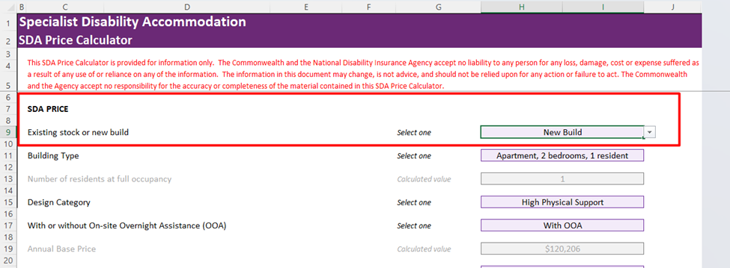

**Building Type, PF is doing,**

* House, 2 residents
* House, 3 residents
* Villa/duplex/townhouse, 1 resident
* Villa/duplex/townhouse, 2 residents

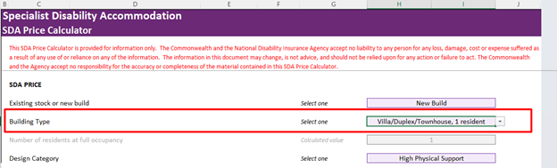

**Design Categories (levels of support)**

1. **Basic** – Housing without specialist design features but with room for carer
2. **Improved Liveability**- Housing has been designed to improve ‘liveability’ by incorporating a reasonable level of physical access and enhanced provision for people with sensory, intellectual or cognitive impairment. (can still walk, but mentally disabled)
3. **Fully Accessible**- Housing is designed to assist people with significant physical impairment by providing a high level of physical access features. A person with significant physical impairment experiences an extreme or complete loss of the ability to perform one or more self-care or self-management functions.
4. **Robust** housing is designed and built to be resilient and provide high physical access provisions. This is achieved by using products, materials and features that minimize risk to participants and the community and reduce the chance of reactive maintenance.
5. **High Physical Support** includes features that provide enhanced physical access provisions for people with significant physical impairment who have very high support needs. (sits in a wheelchair and cannot do anything mentally)

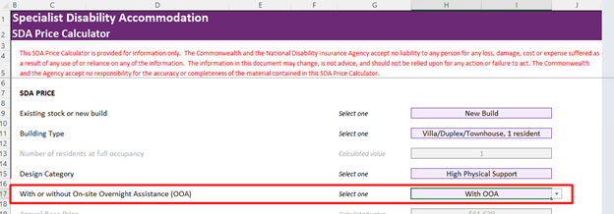

**On-site Overnight Assistance (OOA)** – person with disability employs OOA to look after them

Breakout room is for Robust housing Categories only

Breakout Room, purposefully built to provide a high level of physical access provisions.

**Location**

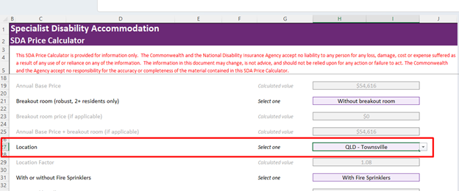

Depending on where the property is you have different multipliers and that is shown in Location Factors Sheet



In this example, 1.08 multipliers,

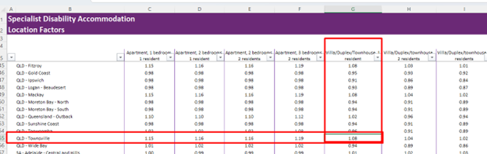

Another option will be adding fire sprinklers

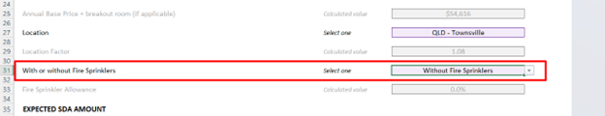

Here is the total expected SDA amount that will come from the government as subsidy

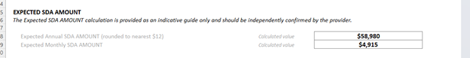

On top of that, here are some additional amounts that will be collected

MRRC - Maximum Reasonable Rent Contribution – This is the amount coming from the tenant

which is an amount that is equal to/per fortnight

* **25 percent** of the maximum basic rate of the Disability Support Pension payable
* Plus: **25 per cent** of the maximum rate of the Pension Supplement payable
* Plus: **100 per cent** of the maximum rate of Commonwealth Rent Assistance payable

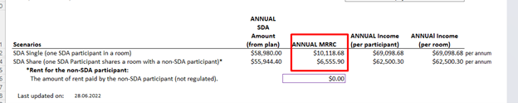

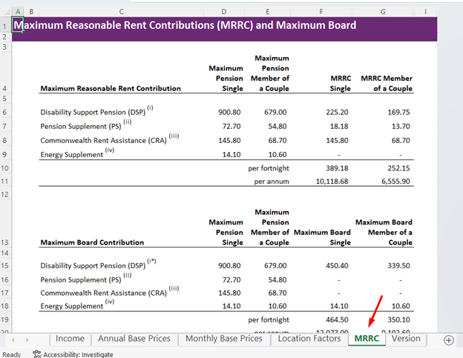

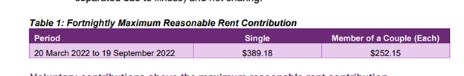



# SDA DWELLING REGISTARTION PROCESS:

**SDA Dwelling Registration – Step-by-Step Guide (NDIS):**

This section outlines the end-to-end process for registering a new dwelling as SDA through the NDIS Provider Portal. It is critical that all mandatory documents are prepared and uploaded together in one submission to avoid delays or rejection.

**STEP 1: PRE-APPLICATION PREPARATION (CRITICAL):**

Before accessing the NDIS portal, the SDA Provider must ensure all required documents are finalised, verified, and available. It is important that all documents must be uploaded at the same time, in one complete submission. Partial or staged uploads will delay assessment.

**Mandatory Documents Checklist**

1. **Recent Rates Notice (Proof of Ownership)**
   * Must be current (generally within the last 12 months)
   * Confirms legal owner(s) of the dwelling
2. **Permission to Enrol Letter** *(Required where Owner ≠ SDA Provider)*  
   The letter must confirm:
   * The owner grants permission to the SDA Provider to enrol the dwelling, and
   * The owner will not separately apply to enrol the dwelling

**Requirements:**

* + Signed by the legal owner(s) named on ownership documents
  + If owner is a company/trust: signed by an authorised representative
  + Must include evidence of authority (e.g. ASIC extract or company/trust extract)

1. **Certificate of Occupancy / Certificate of Completion**
   * Confirms the dwelling is legally complete and fit for occupation
   * Flattened PDF version preferred
2. **SDA Design Standard – Final As-Built Certification** *(New Build / Refurbishment)*  
   Prepared by an **accredited third-party SDA assessor**, including:
   * SDA Assessment Summary Report
   * SDA Compliance Certificate (Final As-Built)
   * SDA Design Checklist (relevant category)
3. **Liveable Housing Australia (LHA) Certification**
   * Required for SDA categories other than **Basic**
4. **Approved Architectural Plans**
   * Council-approved plans (reduced size acceptable)

**STEP 2: ACCESS NDIS PROVIDER PORTAL**

The SDA Provider must:

1. Log in to the NDIS Provider Portal
2. Navigate to the SDA Dwelling Enrolment Portal
3. Select to Create a new application (Enrol / Modify / Cancel SDA Dwelling)

**STEP 3: CREATE DWELLING ENROLMENT APPLICATION**

Within the portal, the SDA Provider must:

1. Enter dwelling and provider details
2. Confirm ownership and permission arrangements
3. Upload **all mandatory documents in one submission**
4. Complete declarations and compliance confirmations
5. Submit the application

**STEP 4: NDIA SDA DWELLING ENROLMENT ASSESSMENT**

Once submitted, the application is assessed by the NDIA SDA Dwelling Enrolment Team.

NDIA Assessment Outcomes

* Approved
  + Certificate of SDA Dwelling Enrolment issued to the provider
* Request for Information (RFI)
  + NDIA requires clarification or missing information
  + Provider must respond via the portal within required timeframes
* Not Approved
  + Formal letter issued outlining reasons for refusal

**STEP 5: RESPONDING TO REQUESTS FOR INFORMATION (IF REQUIRED)**

If an RFI is issued:

1. SDA Provider receives notification via the portal
2. Requested information or documents must be uploaded promptly
3. Application reassessed once RFI response is complete

**INTERNAL RECORD KEEPING (PROPERTY FRIENDS)**

* File status to be marked **"Pending Approval"** until enrolment certificate issued
* Store all documents under the relevant project directory (NDIS / SDA / Property Address / Registration)
* Retain final **Certificate of SDA Enrolment** on file upon approval *and supporting images at each step as required)*

# SDA CLAIMING GOVERNMENT SUBSIDY

# VIA PRODA /BASE (Provider Digital Access)

Claiming of payments are done every 1st of the month

1. Check emails (Statement) coming from rental Agency, (Century 21, Aaron Moon Realty)
   1. Items to check
      1. Rent paid from the tenant
      2. invoice from electric company
      3. 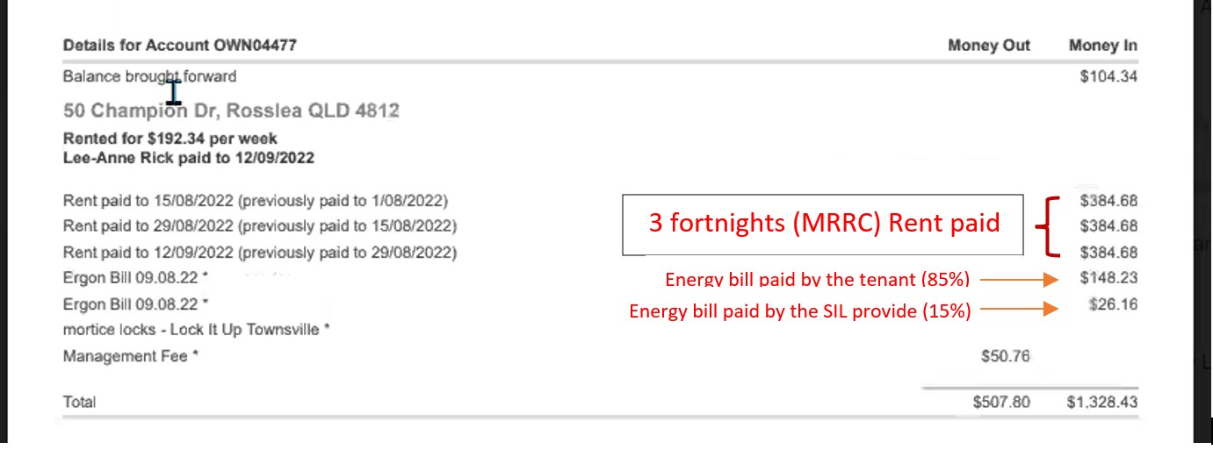any other invoice used for maintenance/repairs of the house

**Pointers:**

Always create new folders of each month containing all attachment to the reconciliation

Saving Path File on each statement and invoice coming from rental agency (google drive)

Shared Drive >> NDIS >> QLD >> Tville >> Rental >> Property number/location folder (e.g. #50 Champion Dve) >> PF Reconciliation >> Reconciliation month (e.g. 2022_09 for August Stmt 13)

1. When all attachment are complete and saved to the folder, we can now do the claim of the government money
2. Go to the URL [https://proda.humanservices.gov.au/prodalogin/pages/public/login.jsf?](https://proda.humanservices.gov.au/prodalogin/pages/public/login.jsf?TAM_OP=login&ERROR_CODE=0x00000000&URL=%2F&OLDSESSION=)
3. Enter log in information
4. Check email for the 2 step verification code



1. Enter the code and make sure show the code before clicking next
2. Click NDIS portal

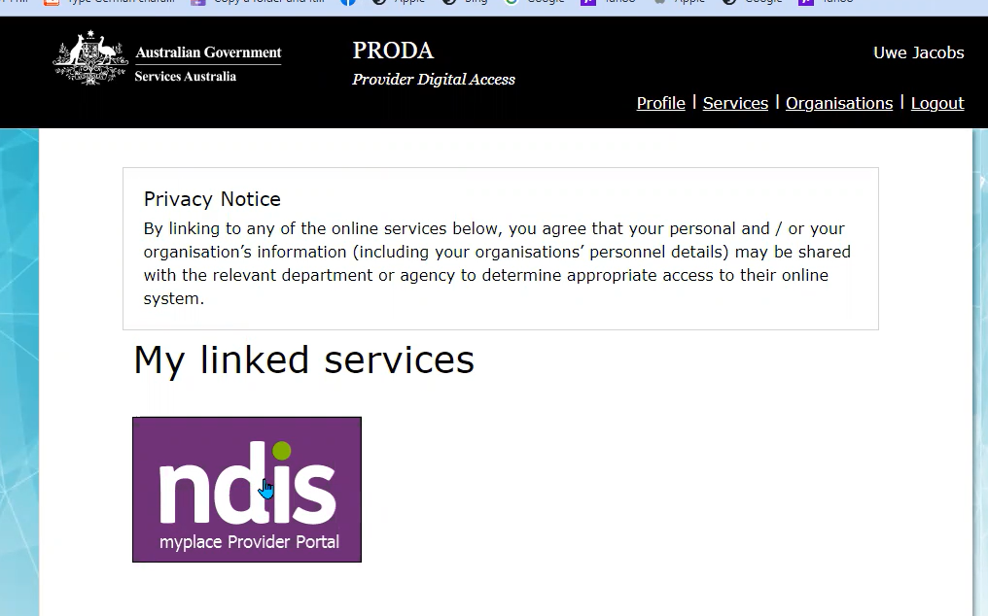

3. Go to My participants

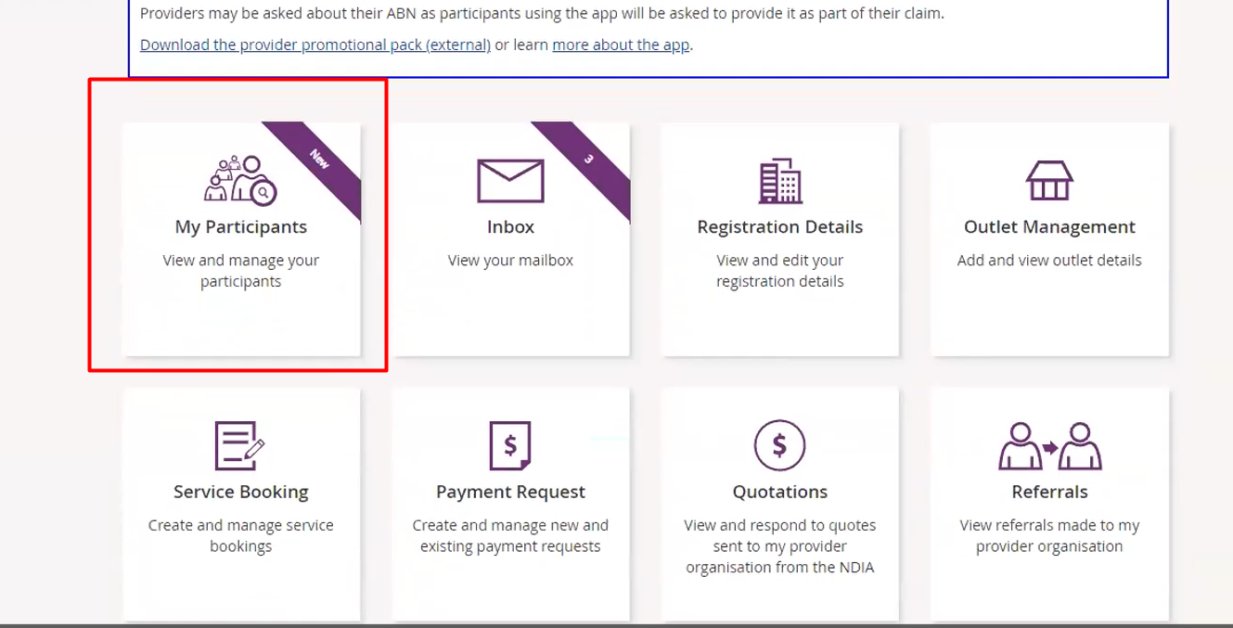

4. Click View to make sure that there is an active plan

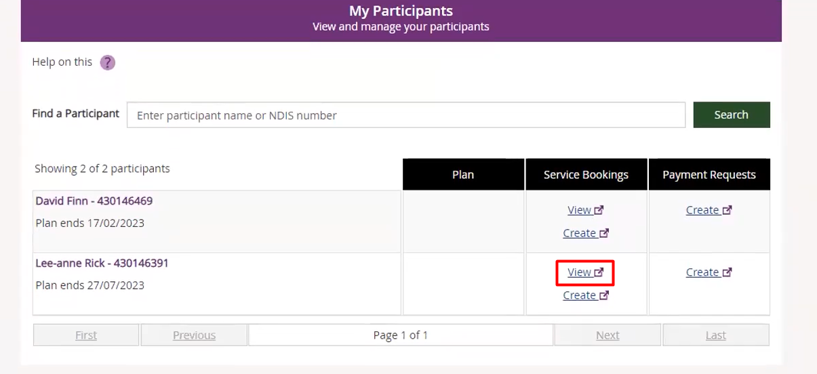

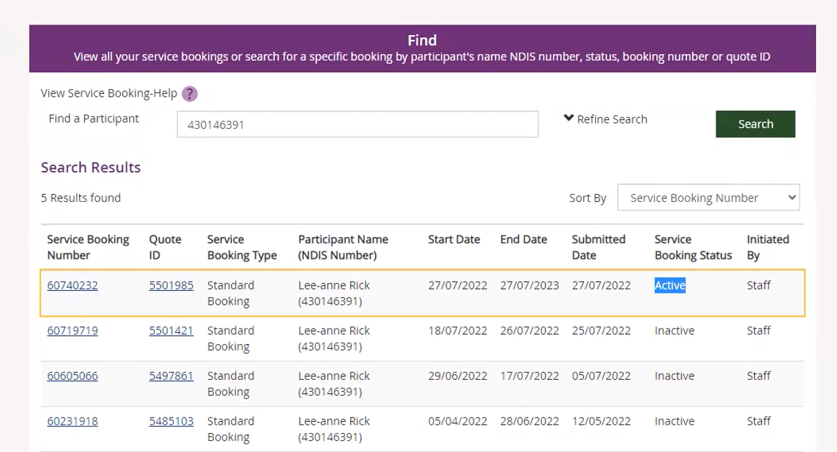

If there are no active plan you cannot claim payments - its like having a quotation, if there is no quotation we cannot place a job

Go into further looking by checking the Service Booking number

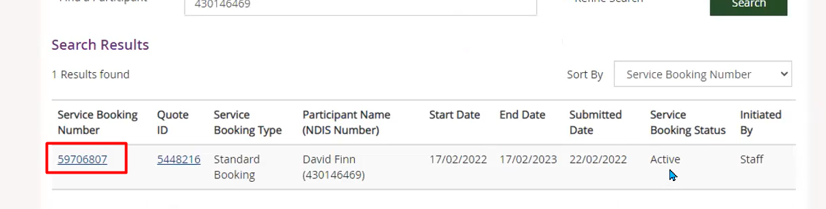

See if there is enough money remaining, remaining amount should be larger what we are claiming monthly

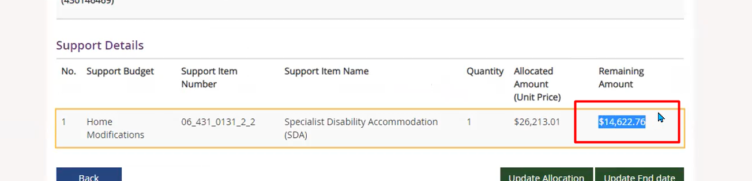

**POINTERS**

***Allocated amount is the amount you can claim annually***

**Every July of each year this amount is getting updated**

5. Next is to Create a Payment request

This section explains the correct sequence for accessing PRODA and lodging NDIS claims via the MyPlace Provider Portal. Due to security controls, real-time coordination with Uwe is mandatory for login. Before, attempting to log in please Notify Uwe via Google Chat that you intend to access PRODA Login requires a real-time passcode from Uwe’s phone. Do not proceed unless Uwe is available to provide the code

**PRODA LOGIN**

1. Log in using the email address:  
   [**uwe@propertyfriends.com.au**](mailto:uwe@propertyfriends.com.au)
2. Access PRODA via the **NDIS login page**
3. You will be redirected to **myID** for authentication
4. Select **“Remember my choice”** (recommended)
5. Click **“Select myID”**
6. Click **“Get Code”**

1. Uwe will provide and confirm the passcode **in real time**

**STEP 3: SELECT ORGANISATION**

Once authenticated:

1. Select “The Trustee for UWE Property Consulting Trust”
2. Click through to NDIS MyPlace Provider Portal
3. The main MyPlace dashboard will load

**STEP 4: NAVIGATING MYPLACE – CLAIMS & RECORDS**

Within the MyPlace Provider Portal, you can:

**A. Submit Claims**

* Navigate to Payment Requests
* Select Bulk Payment Request
* Follow the standard NDIS bulk claims procedure

**B. Participant Information**

* Use **My Participants** to:
  + Confirm participant details
  + Verify service bookings
  + Change dates for CSV file and ensure it is aligned with US Date format YYY/MM/DD and then upload it in the section. Make ensure NDIS no of participants is mentioned correctly.

# SDA CLAIM FOR AGENCY MANAGED PARTICIPANTS

This section explains the process for claiming SDA payments for Agency Managed participants, which differs from PRODA/MyPlace claims. For Agency Managed participants, claims are made via invoicing to the participant’s Plan Manager, not through the MyPlace portal.

**OVERVIEW**

* SDA payments for Agency Managed participants are claimed monthly
* Claims are based on a finalised SDA Reconciliation Sheet for the relevant month
* Invoices are issued by Ulla to the relevant Plan Manager
* Payments are received directly by Property Friends (PF)

**STEP 1: FINALISE SDA RECONCILIATION SHEET**

At the end of each claim period:

1. Prepare and review the **SDA Reconciliation Sheet** for the month
2. Confirm:
   * Participant occupancy
   * Applicable SDA category
   * Correct MRRC and SDA amounts
   * Any adjustments or pro-rata calculations
3. Ensure figures are accurate and internally approved before proceeding

**STEP 2: REQUEST INVOICE ISSUANCE**

Once the reconciliation is finalised, submit a request to **Ulla** to issue invoices.

**Information to Include in the Request**

Each participant must be listed separately with the following details:

* Participant Name (e.g. Mario)
* Property Address / Property Name
* NDIS Number
* Date of Birth (DOB)
* NDIS Item Number (SDA line item)
* Claim Coverage Period (from–to dates)
* Claim Amount (as per reconciliation sheet)

**STEP 3: INVOICE ISSUANCE BY ULLA**

* Ulla prepares the invoice based on the information provided
* Invoice is issued to the relevant Plan Manager for each participant
* Invoice references the participant, property, SDA item number, and claim period

**STEP 4: PAYMENT RECEIPT**

* Plan Manager processes the invoice
* Payment is made directly to Property Friends (PF)
* Payment receipt is monitored and recorded for reconciliation purposes

**STEP 5: RECORD KEEPING & FOLLOW-UP**

* File issued invoices and remittance advice in the participant/property folder
* Update internal tracking to confirm payment status
* Follow up with the Plan Manager if payment is delayed

**KEY COMPLIANCE NOTES**

* SDA Reconciliation Sheet must be finalised **before** invoicing
* All participant details must match NDIS records exactly
* Incorrect or incomplete information may delay payment
* Agency Managed SDA claims are **not submitted via PRODA/MyPlace**

# RECONCILIATION SPREADSHEET

This is a spreadsheet being sent to the Client (property owner) each month, this is under a private folder - but Uwe will transfer to the shared folder

File name should be - Reconciliation Stmt # for (month)

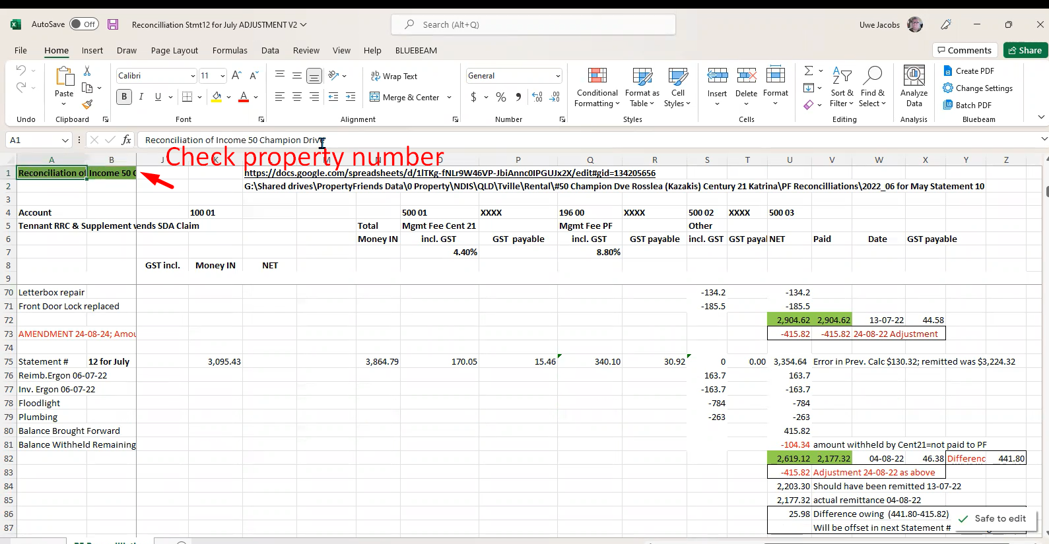

First, Copy items from the previous month, leave two empty row, paste in a new empty row, and update data accordingly

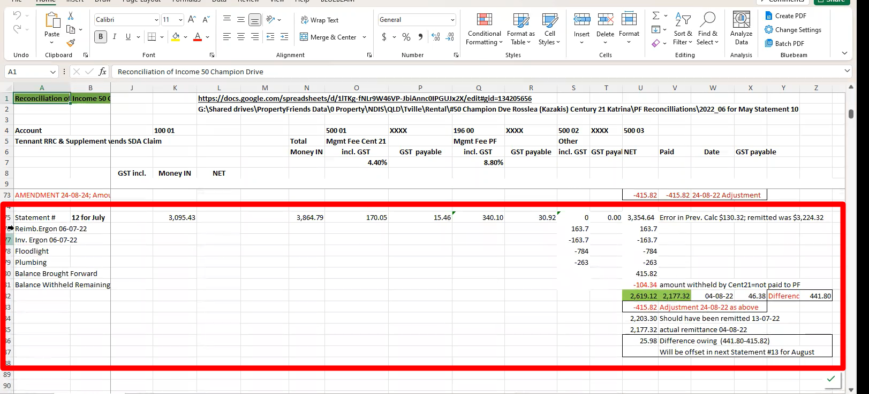

1. Update the Figures from the monthly statement from the Rental Agency
   1. Statement # and month

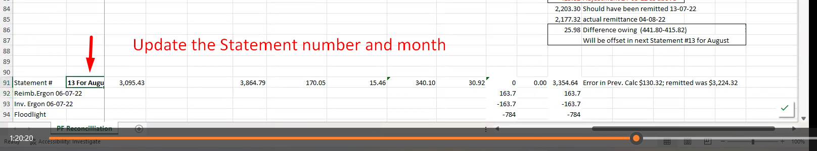

2. Update the figure, check the statement from the Rental Agency

3. Let's update from the top down, enter the value of each item to the spreadsheet

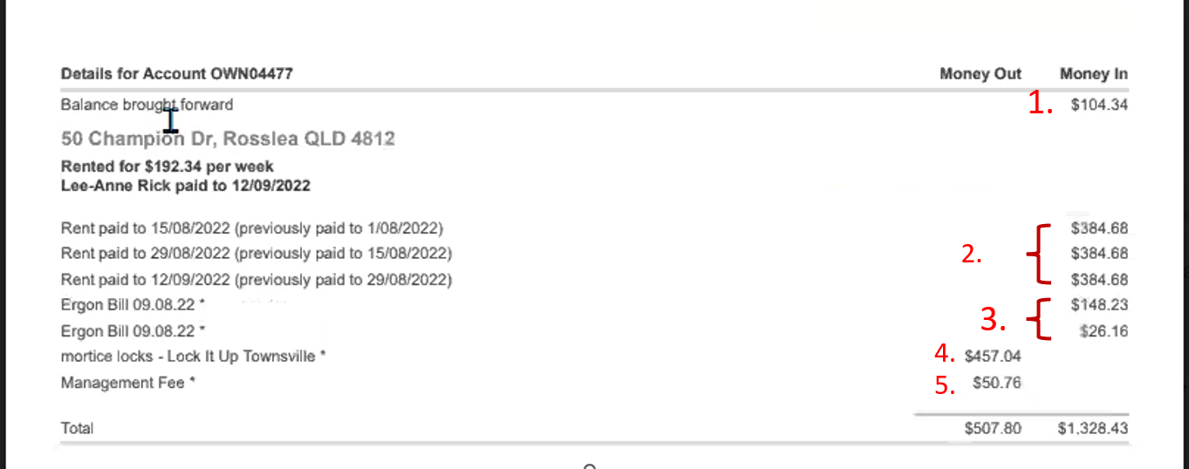

Under Column Heading **NET** Enter each amount

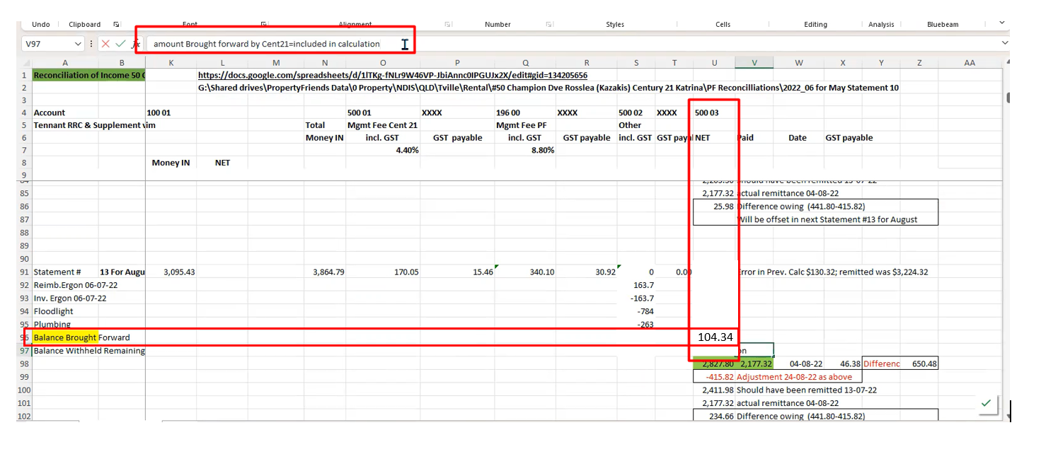

Enter in (Column) **Money IN**, (Row) **Statement #** then total rent paid amount

Management fee (column) Management Fee

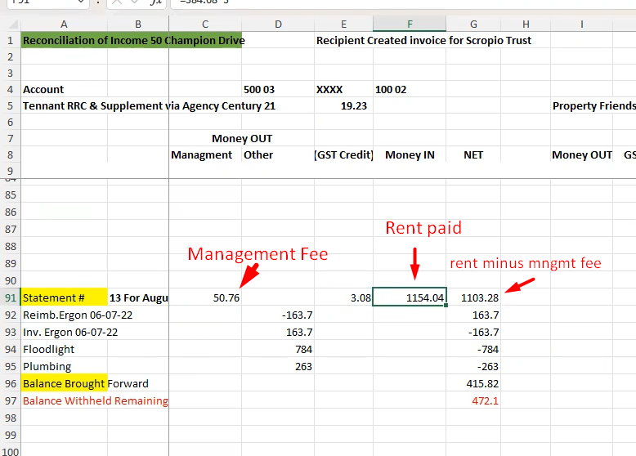

Enter the reimbursement for the energy consumed from the tenant and SIL

Then under invoice enter the invoice amount from energy company, it should come up to zero because basically this amount has been matched to the invoice

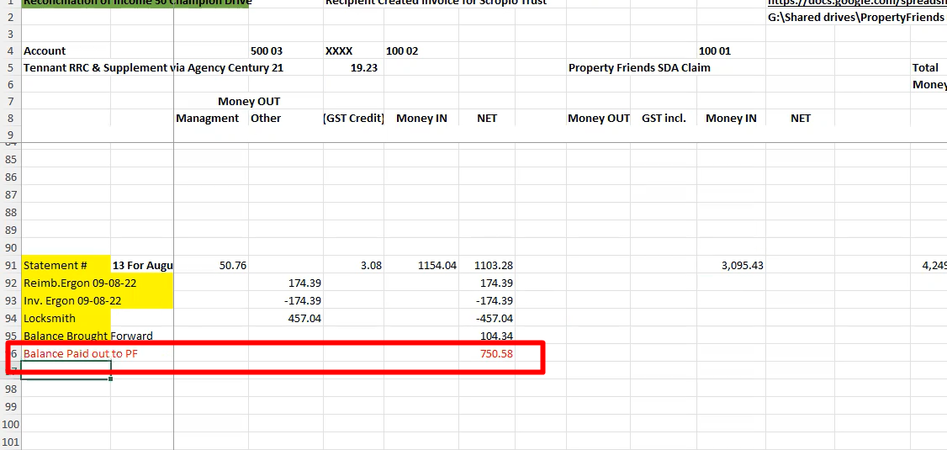

The amount in total should match the amount listed in the statement.

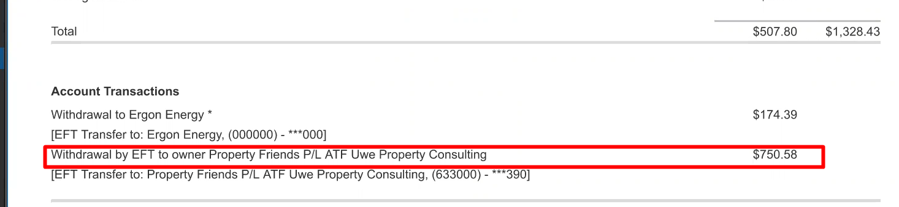

Enter Figure from PRODA claim

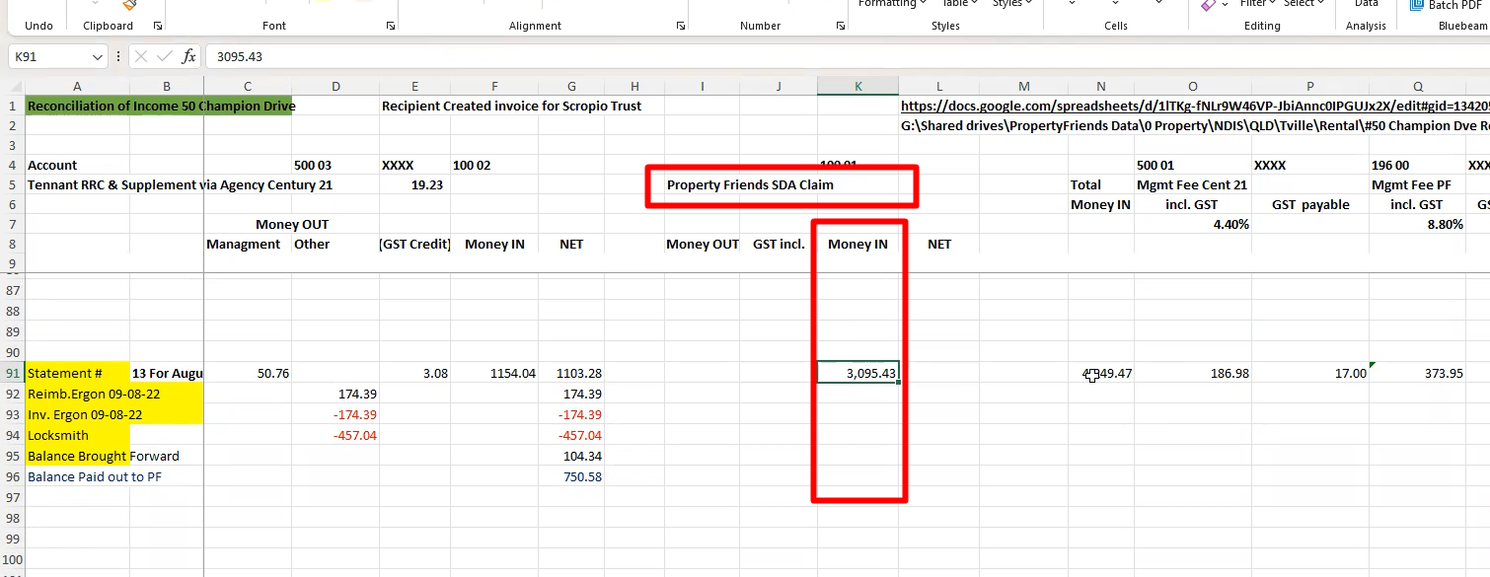

Total money in is the sum of month rent and the subsidy from the government

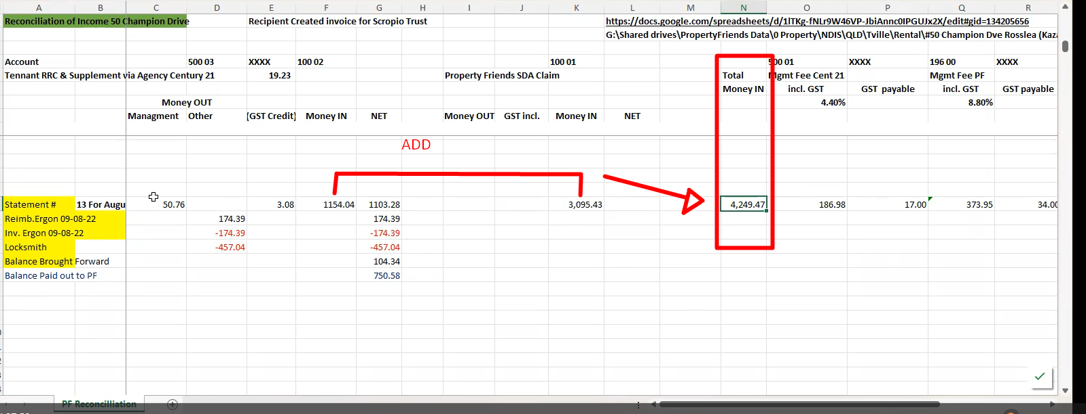

**Rental Agency will get 4.40% from the Total Money IN**

***Is the GST Payable same every month?***

**Property Friends get 8.8% from the total Money IN**

This is the amount total to pay to client

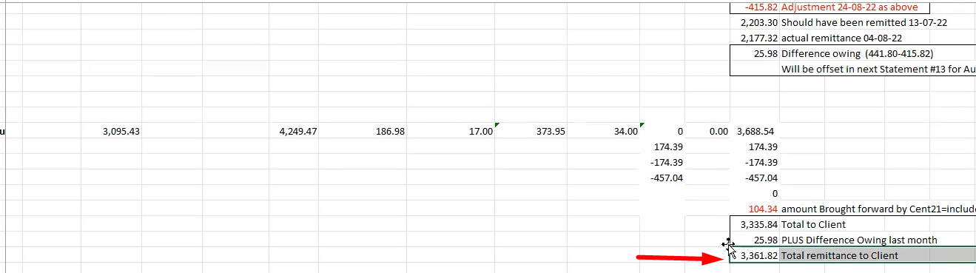

Then save to PF reconciliation folder

**TRAINING RECORDING LINKS:**

[**https://drive.google.com/drive/folders/1cOqyNLP8yRLAlZVqnQS9SWvf670VuPhn**](https://drive.google.com/drive/folders/1cOqyNLP8yRLAlZVqnQS9SWvf670VuPhn)

[**https://drive.google.com/drive/folders/1cOqyNLP8yRLAlZVqnQS9SWvf670VuPhn**](https://drive.google.com/drive/folders/1cOqyNLP8yRLAlZVqnQS9SWvf670VuPhn)

[**https://drive.google.com/drive/folders/1A5yN5PJ0hTt-CM6CiFW8RAybpVdz8Z9D**](https://drive.google.com/drive/folders/1A5yN5PJ0hTt-CM6CiFW8RAybpVdz8Z9D)